F3J Baltic Open 2007.

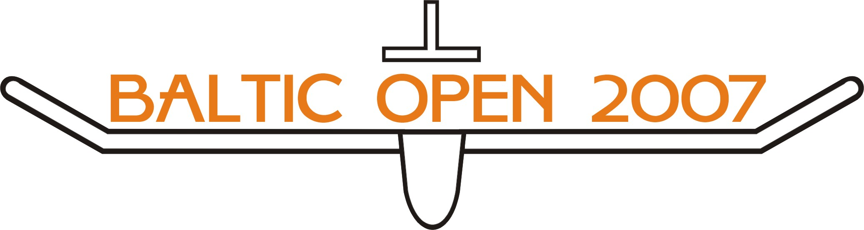

Competition guide

Estonian, Latvian and Lithuanian Aeronautical Federations are pleased to invite you to participate in series of Baltic Open competitions for Radio Controlled Thermal Duration Gliders, Class F3J, which will be held in three Baltic States in 2007. Additional information will be available in further bulletins that will be provided by the organisers of the single competitions.

Competition: Baltic Open for Thermal Duration Gliders, Class F3J. The Baltic Open consists of series of competitions held in three different countries. Two competitions in each country. Entries are welcome from individuals and (optionally) teams. Seniors and juniors will fly together. A competitor is considered to be a junior throughout the year in which he attains the age of 18.

Teams: Teams are consisted of three pilots. Teams do not have to (and preferably should not) be national. To be decided in the breefing of the first event.

Date and Place:
Latvia
Organizer: Aeroclub.....
09.06.2007-10.06.2007 Nakotne Cup Cesis Northern Part of Latvia
Contact person: Aleksandrs Sergejevs
Tel: +371-29223651
Email: al@presesnams.lv
Web: http://www.nakotne.com/news.php
Organizer: Aeroclub.....
28.07.2007-29.07.2007 Juri Cup Kuldiga Western Part of Latvia
Contact person: Juris Geide
Tel: +371-26541405
Email:
Web:

Lithuania
Organizer: Aeroclub.....
26.05.2007-27.05.2007 Mazeikiai taure Mazeikiai
Contact person:
Tel:
Email:
Web:

Organizer: Aeroklub.....
04.08.2007-05.08.2007 Alytaus taure Alytus
Contact person: Gintaras Kuckailis
Tel: +370 698 77366 mob.
Email: pavietre@yahoo.com
Web:

Estonia
Organizer: Aeroclub FUNFLY
12.05-13.05 Riidaja, Torupillitalu

Contact person: Edvin Penart
Tel: +372-53425767
Email: penart@hot.ee
Web: www.mudellend.ee

Organizer: Aeroclub TARTU MK
30.06-.01.07 GLIDERFEST, Nurmsi,
Contact person: Heino Kõrvel
Tel: +372 428368
Email: heino@tragi.ee
Web: www.mudellend.ee

Location: Location for each competition will be described in the bulletin of each competition. Each competition organiser has to provide accurate map and route plan.

Schedule: The organiser has to propose in the Bulletin time schedule of the event. Prior to the start of the competition the nominated Jury will decide and announce the number of rounds to be flown. The intent will be to fly as many rounds as can be reasonably accommodated in to one day allocated for flying

Applications: Closing date for applications is one week before the competition. Entry forms to be sent to competition organiser/contact person by e-mail.
Preliminary entries are welcome as soon as this Competition guide is approved. All preliminary entries will be published on web page: http://www.nakotnes.com

Entry fee: Seniors 10 EUR
Juniors 5 EUR

These fees do not include any meals or accommodation.
All entry fees will be paid at the competition sight.

Entry form: Entry form is attached to the present Competition Guide. Please fill this form in computer and send it to the competition organiser by e-mail.

Regulations: The competition is organized in accordance with FAI Sporting Code, section 4b and 4c. It will be allowed to use for model launch F3B winches, fulfilling FAI Sporting Code, section 5.3.2.2. Distance between winch line and pulleys 150 m.

Jury Prior to the start of the single competition the Jury, consisting of representatives of each participating country, has to be nominated.

Scoring: There will be in each competition and for the whole Baltic Cup overall scoring and Junior scoring

The Total score of the individual competitor for the whole Baltic Cup will be calculated as the sum of the best results achieved in each country (i.e. the best result achieved in Lithuana + the best result achieved in Latvia + the best result achieved in Estonia).

In each competition:
One worst score from qualifying rounds will be deducted if more than 5 rounds are flown.
Based on qualification rounds two finals, A and B will be flown. Those finals shall be based on overall ranking.
6 best will go to A finals.
Places 7-14 will go to B final. Working time in B final is 1 x 10 minutes. 2 best from B final will go to A finals.
Two A finals will be flown, working time in each 15 minutes. Final placing of the 8 competitors, who qualified for the A finals, shall be determined by their aggregate scores over the two A finals.
Places 9-14 shall be determined by the results of B final
For Baltic Cup ranking points will be awarded as folloving:
1 place - 40 points, 2 place - 30 points, 3 place - 20 points, 4 place - 15 points, 5 place - 10 points, 6 place - 9 points, 7 place -8 points …
14 place -1 point.

Prior to the abovementioned A and B finals final for juniors will be flown: 4 best juniors from qualifications, working time 1 x 15 minutes. Juniors will be awarded for Baltic Cup ranking as following: 1 Place – 4 points, 2 Place – 3 points etc.

Results: Will be posted on boards during the competition. Online results will be available through whole competition season, on web page: http://www.nakotne.com

Prices: Each competition organizer will be free to give any kind of trophies, award or prize for first three or even more competitors in overall and Junior rankings. The final prize giving ceremony of the Baltic Cup will be held on last competition of the season.

Official language: English

Insurance: Organisers are not responsible for any kind of damage caused by competitors to themselves or to the third parties.

Electricity: Organizers are not obligate to accommodate the competitors with electricity, but it is strongly recommended if it is possible.

Frequencies: The following RC frequencies are allowed for use by the aero modellers in Estonia:
Frequency(MHz) Channel-Nr. Frequency(MHz) Channel-Nr.
35,000 60 26,995 4
35,010 61 27,045 9
35,020 62 27,095 14
35,030 63 27,145 19
35,040 64 27,195 24
35,050 65
35,060 66 40,665 50
35,070 67 40,675 51
35,080 68 40,685 52
35,090 69 40,695 53
35,100 70
35,110 71
35,120 72
35,130 73
35,140 74
35,150 75
35,160 76
35,170 77
35,180 78
35,190 79
35,200 80
35,210 81
35,220 82

The following RC frequencies are allowed for use by the aero modellers in Latvia:
Frequency(MHz) Channel-Nr. Frequency(MHz) Channel-Nr.

The following RC frequencies are allowed for use by the aero modellers in Lithuania:
Frequency(MHz) Channel-Nr. Frequency(MHz) Channel-Nr.

Protest Fee: A protest may be submitted in accordance with the FAI Sporting Code, Section 4b, item B.14, accompanied by a protest fee of 20 EUR, refundable if the protest is approved.

Accommodation: Each organizer has to describe briefly the accommodation possibilities on the event. Possible solutions could be:
Camping:

Hotels:

Apartments:

Contact:
Estonia
E-mail: Priit Leomar [Priit@eli.ee]
Web: http://mudellend.ee
Phone: +372 53917538

Latvia
E-mail: Aleksandrs Sergejevs [al@presesnams.lv]
Web: http://www.nakotne.com/news.php
Phone: +371-29223651

Lithuania
E-mail: Gintaras KUCKAILIS [pavietre@yahoo.com]
Web:
Phone:

Further information and changes is to be announced in next Bulletin.

Welcome to the Baltic Cup!!!

Please fill this form on computer, or if with hand please use CAPITAL letters. Form must be filled with correct information that is required.

Country: |  | Date of application:

National Aero Club:
Address:
City:
Phone: |  | Fax:
Web page: |  | E-mail:
Contact person:

FAI licence Nr.: | Frequencies:  Each competitor must have minimum two frequencies for use and valid FAI Licence.

Accommodation: | Hotel (name) | Apartments (name) | Camping on Airport
Number of persons:
Date for reservation:

Other information that we as organisers need to know:

